

Experiment No.: 05

Title: Continuous Integration with Jenkins and GitHub
Batch: B–1 Roll No.: 16010422234 Experiment No.: 05
_____________________________________________________________________________

Aim: Continuous Integration with Jenkins, Git and GitHub for each build.
_____________________________________________________________________________

Resources needed: Jenkins, GitHub Account
_____________________________________________________________________________

Theory:
Implementing Continuous Integration (CI) can reduce errors in code, shorten development cycles, and help your team ship software faster.

Why does CI matter?
Companies need to release software faster than ever, and CI has become an important part of keeping up. With CI in place, teams can build, test, and update their code within minutes, increasing quality and reducing time to production.
With so much change in the tech field, teams can use many different kinds and combinations of tools. That’s why our focus is on making life easier for as many developers as possible, giving teams the freedom to integrate with the best tools out there. Today, GitHub integrates with hundreds of third party tools, including some of the most popular and well-documented integrations around—all available from Marketplace and the Works with GitHub directory.

How does it work with GitHub?
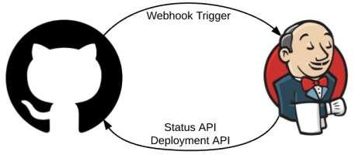
Jenkins scans your entire GitHub organization and creates Pipeline jobs for each repository containing a Jenkinsfile — a text file that defines the process of building, testing, and deploying your project using Jenkins. Immediately after code is checked in or a new pull request is created, Jenkins will execute the Pipeline job and return the status to GitHub indicating whether it failed or succeeded. This process allows you to run a build and subsequent automated tests at every check in so only the best code gets merged. Catching bugs early and automatically reduces the number of problems introduced into production, so your team can build better, more efficient software.
Deployments that occur in Jenkins can also be recorded back into GitHub to audit the entire lifecycle.
_____________________________________________________________________________
Procedure:

- Write any program and push it on GitHub
- Integrate Jenkins and GitHub
  - Install Git plugin on jenkins
  - Create a project on Jenkins and configure it for Git SCM
- Run Git Push command to commit the modified code on GitHub
- Check the changes on the GitHub and Jenkins for continuous integration for each build.
_____________________________________________________________________________

Results: (Document with screenshots)

- All steps of GitHub integration, configuration and execution with modification of code for each build.

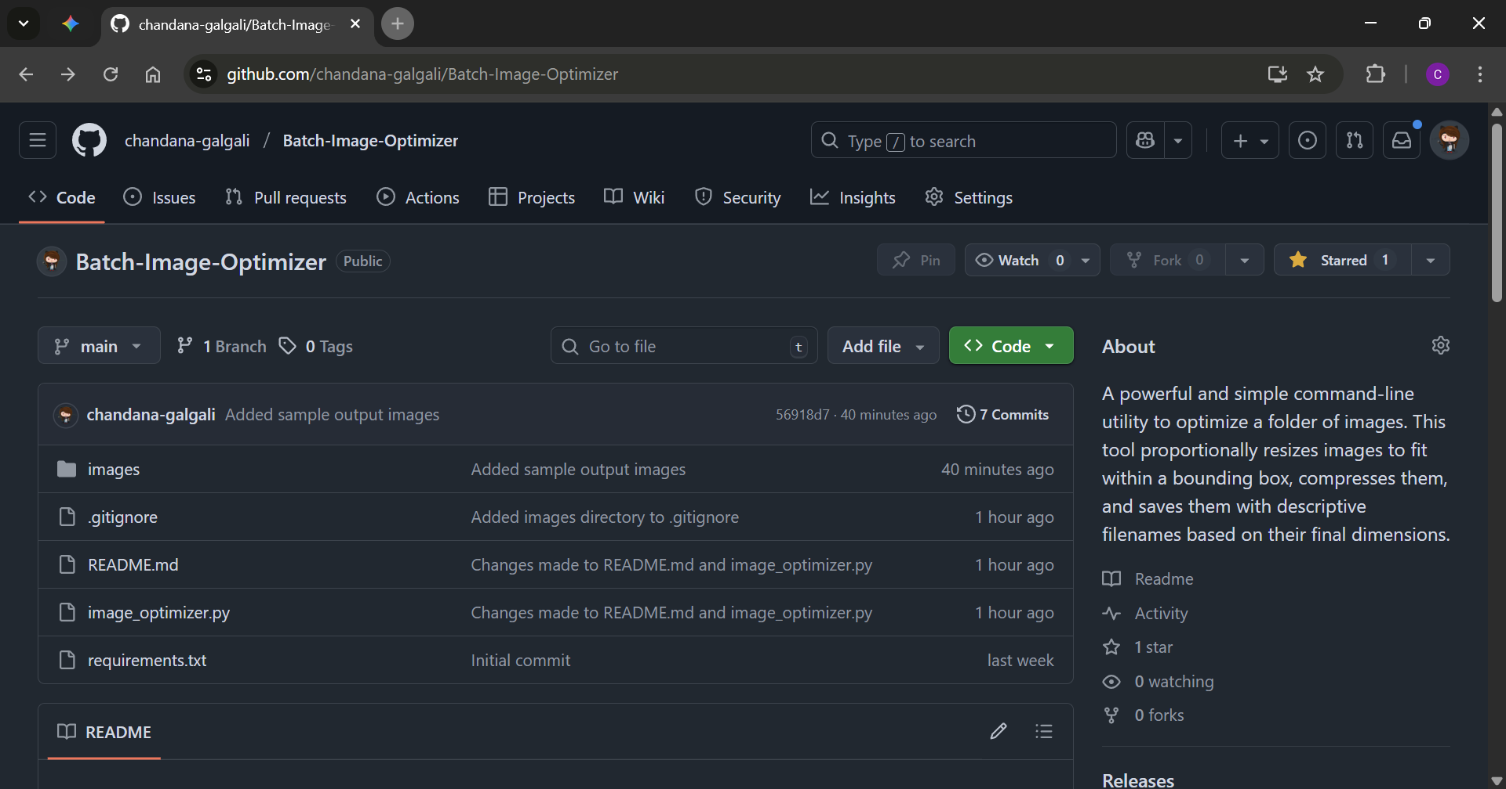

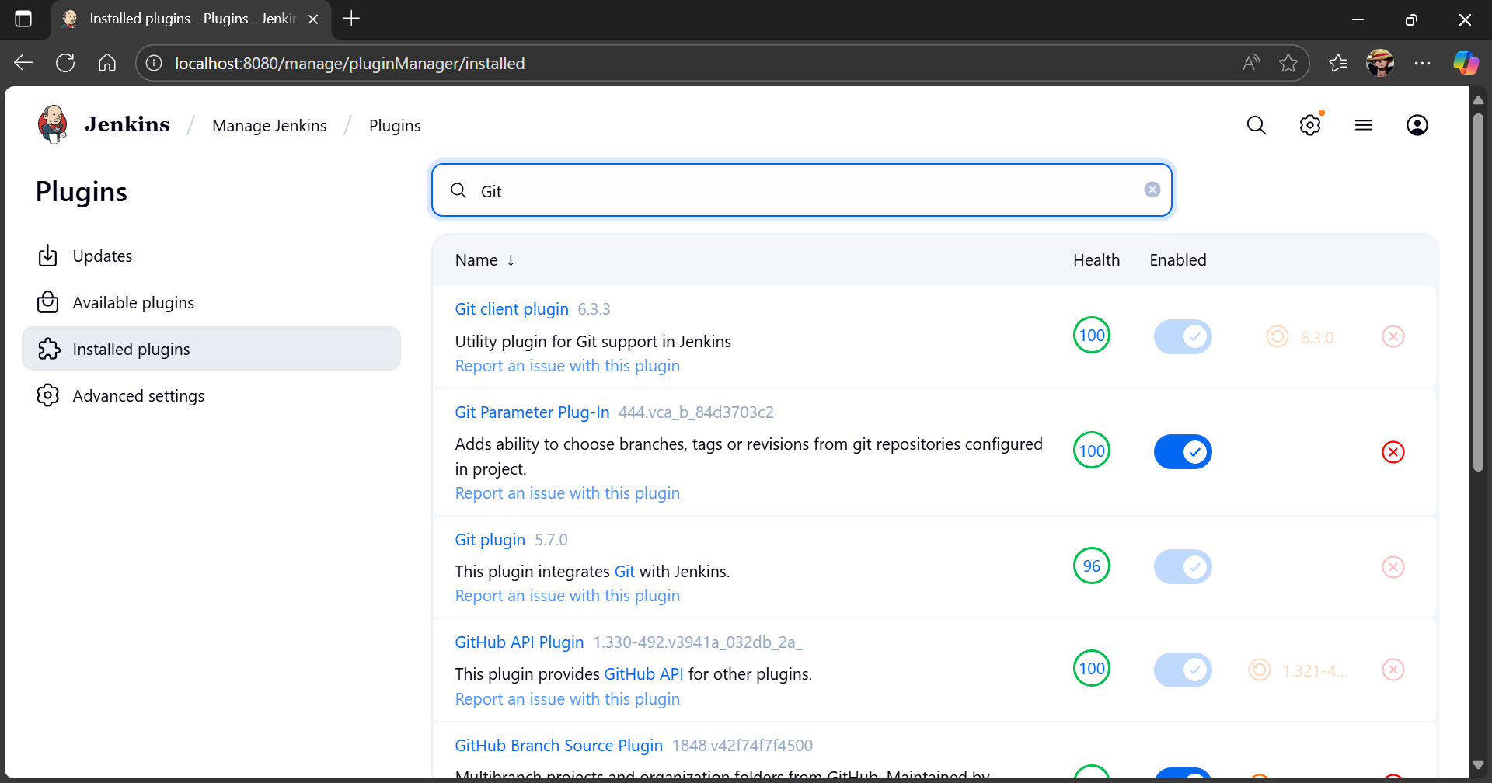

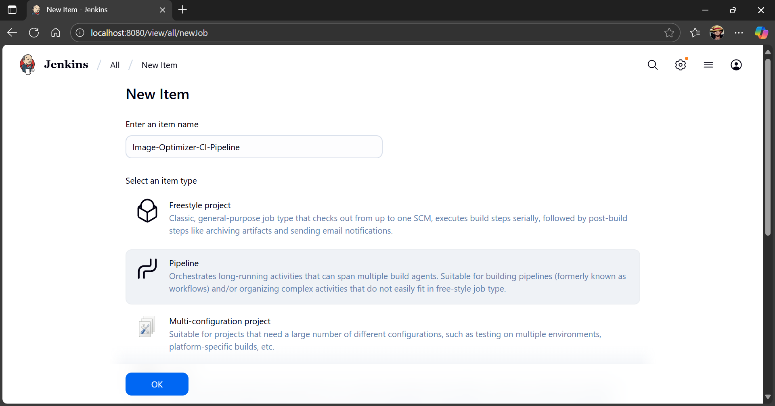

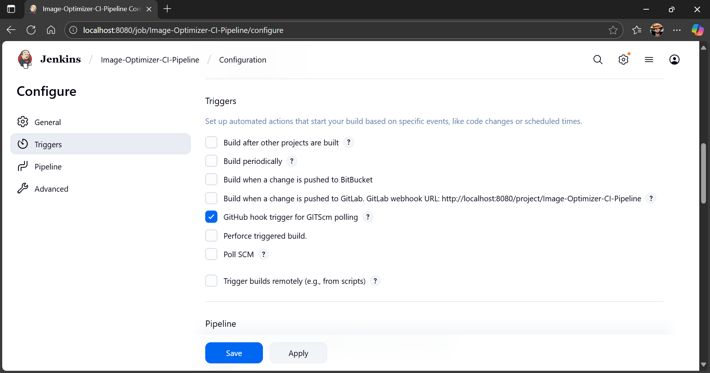

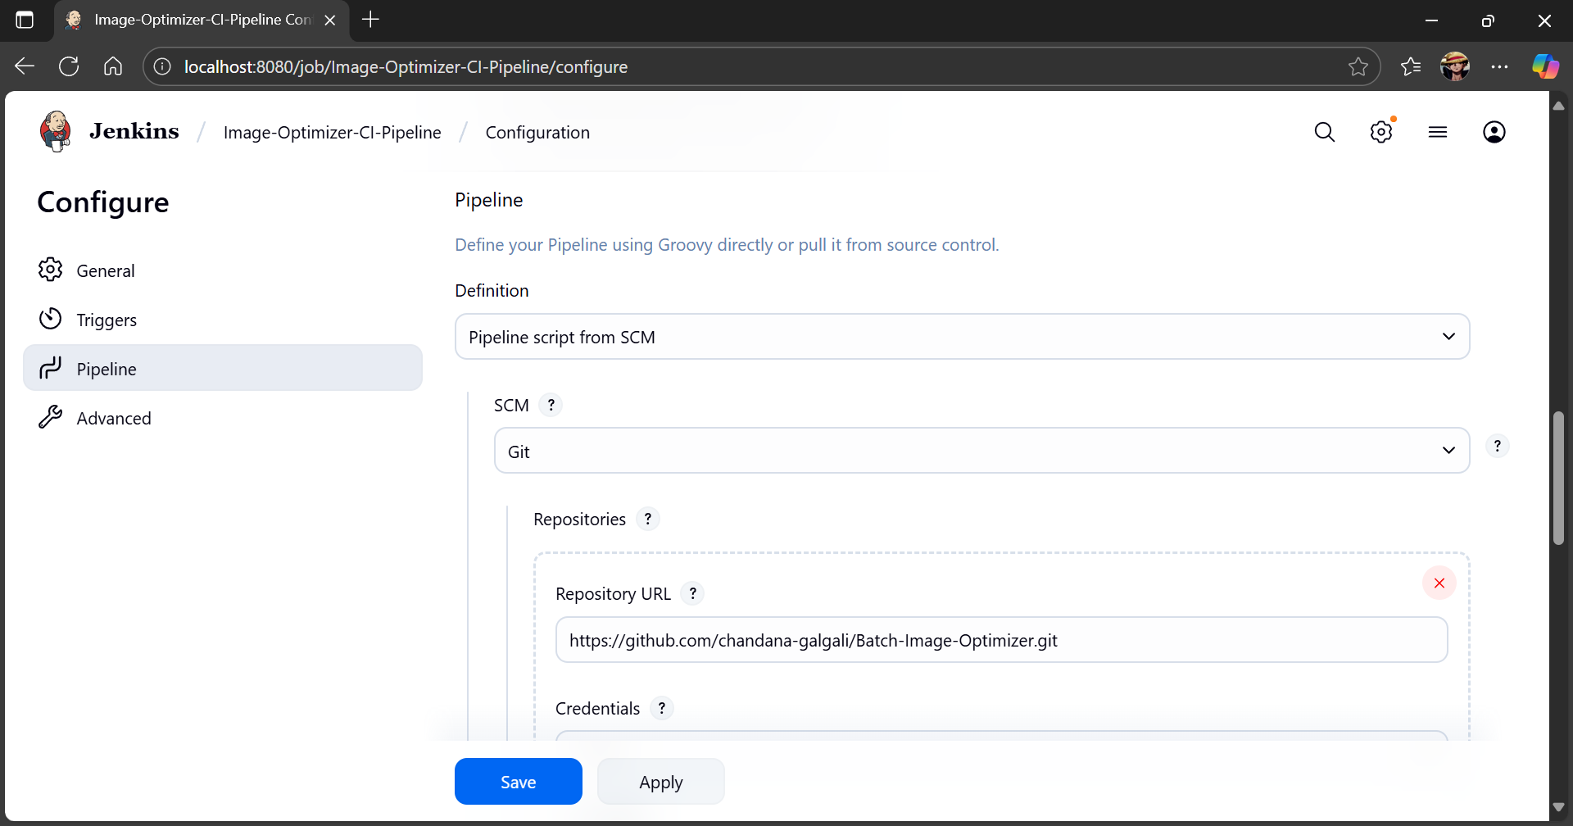

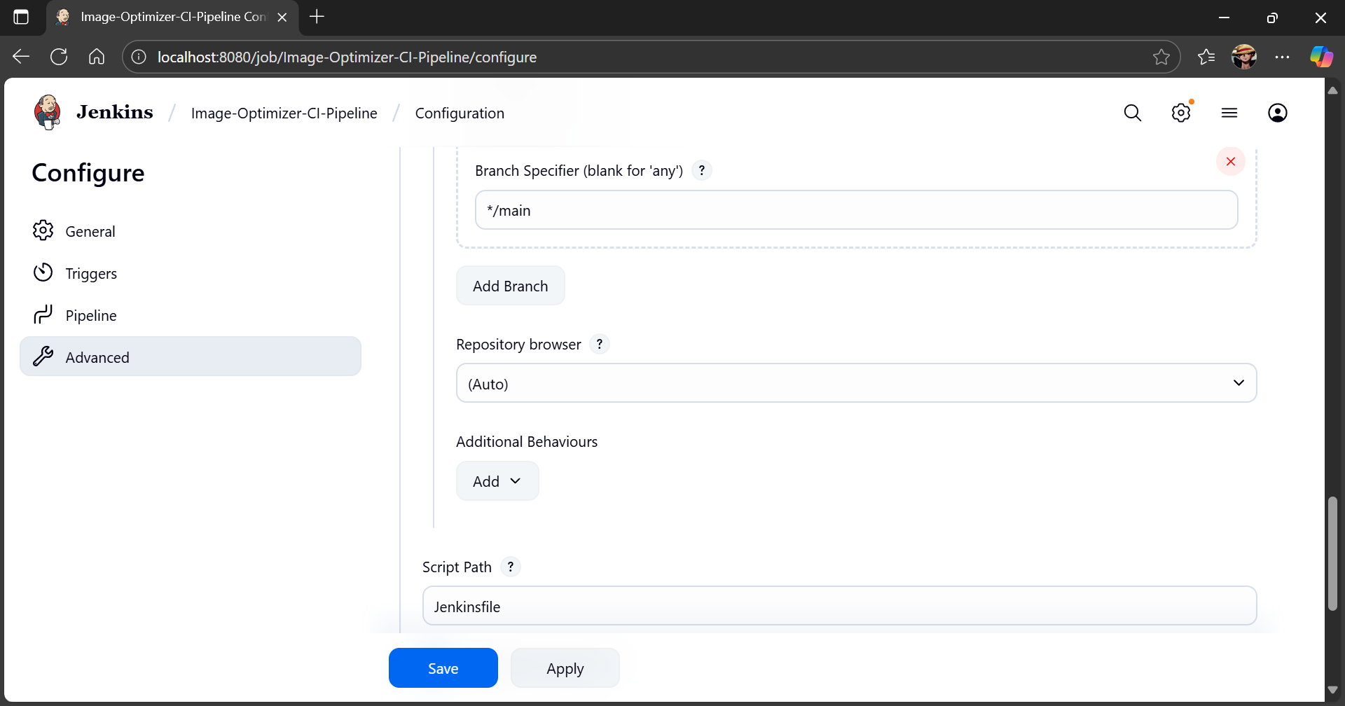

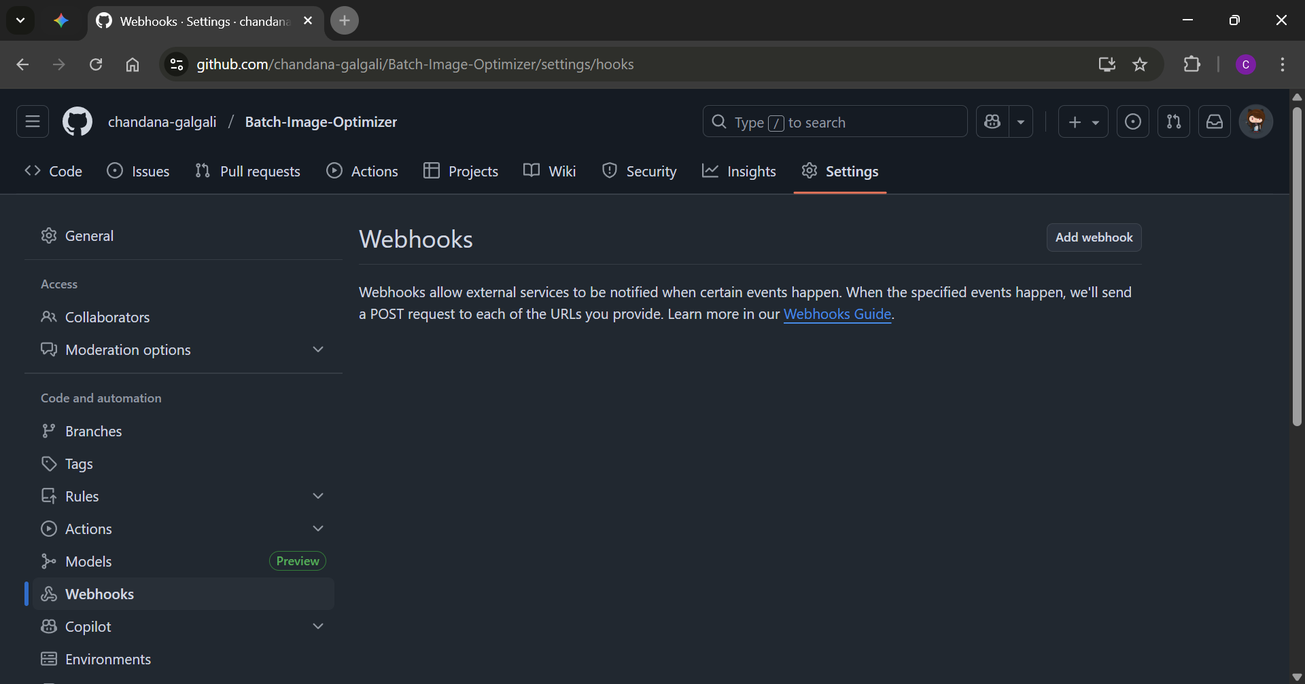

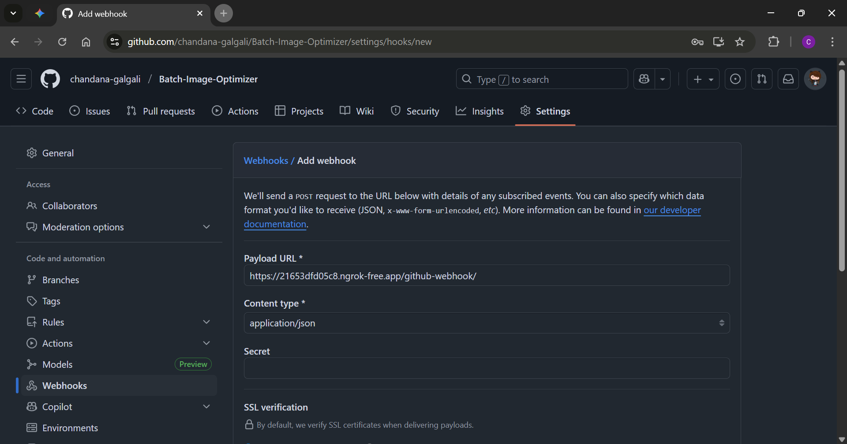

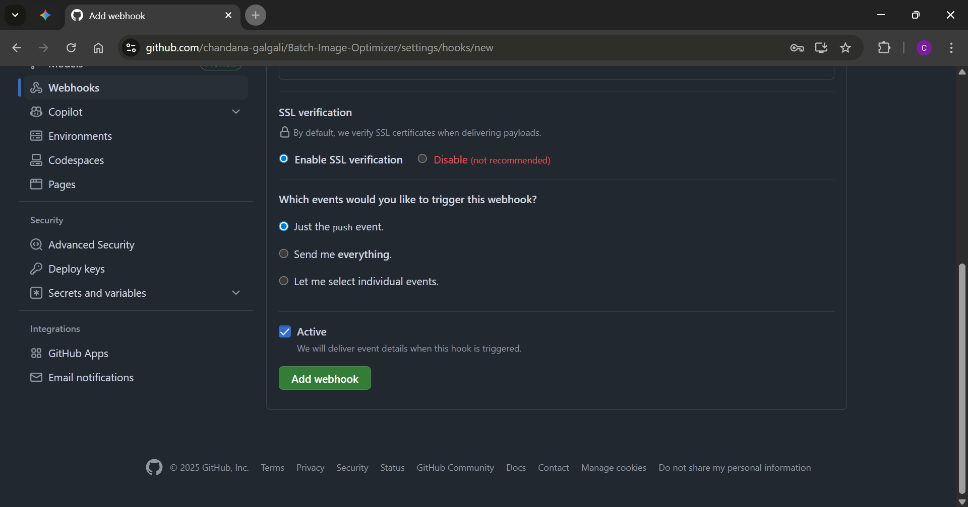

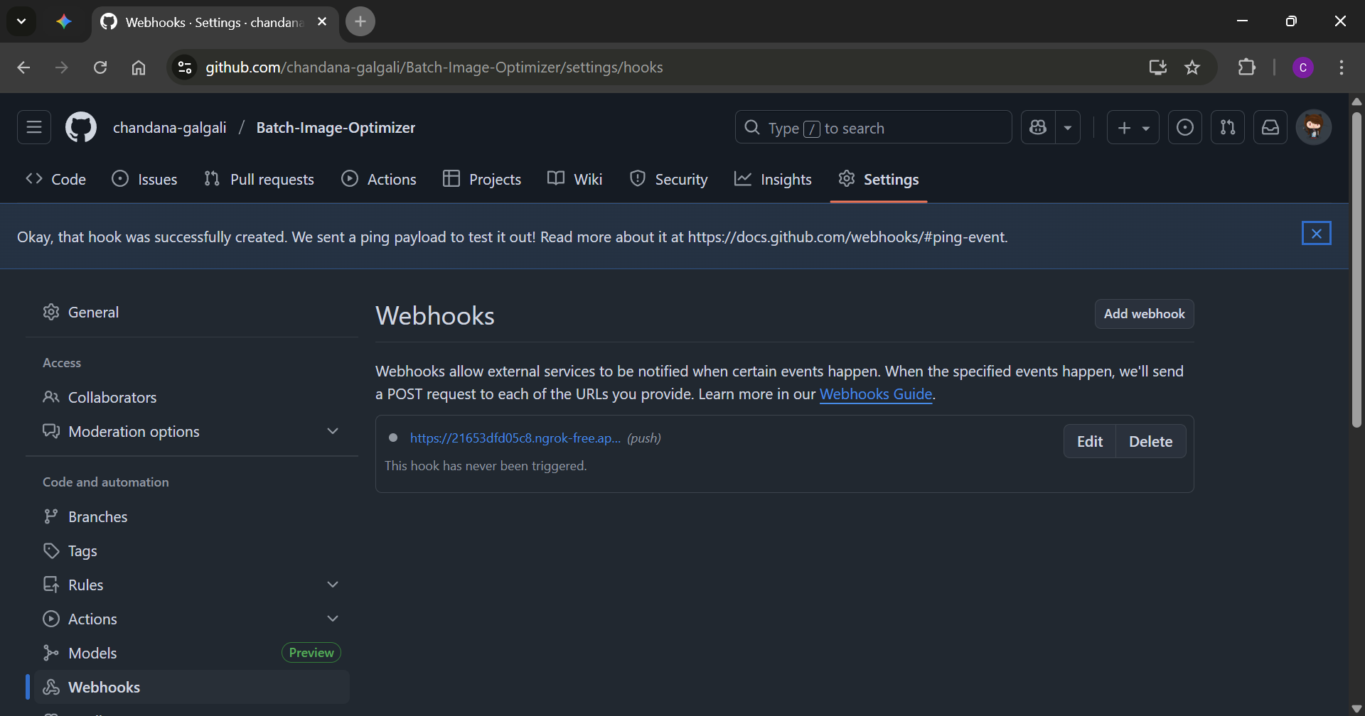

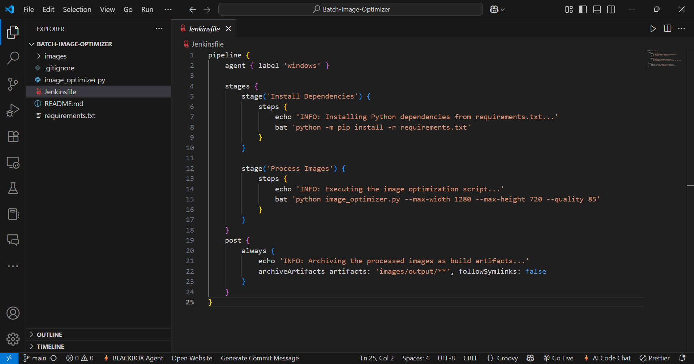

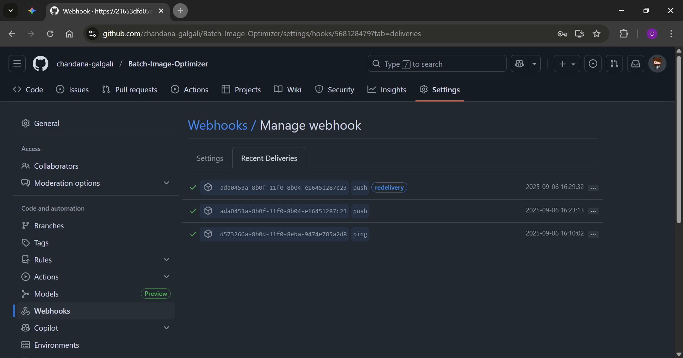

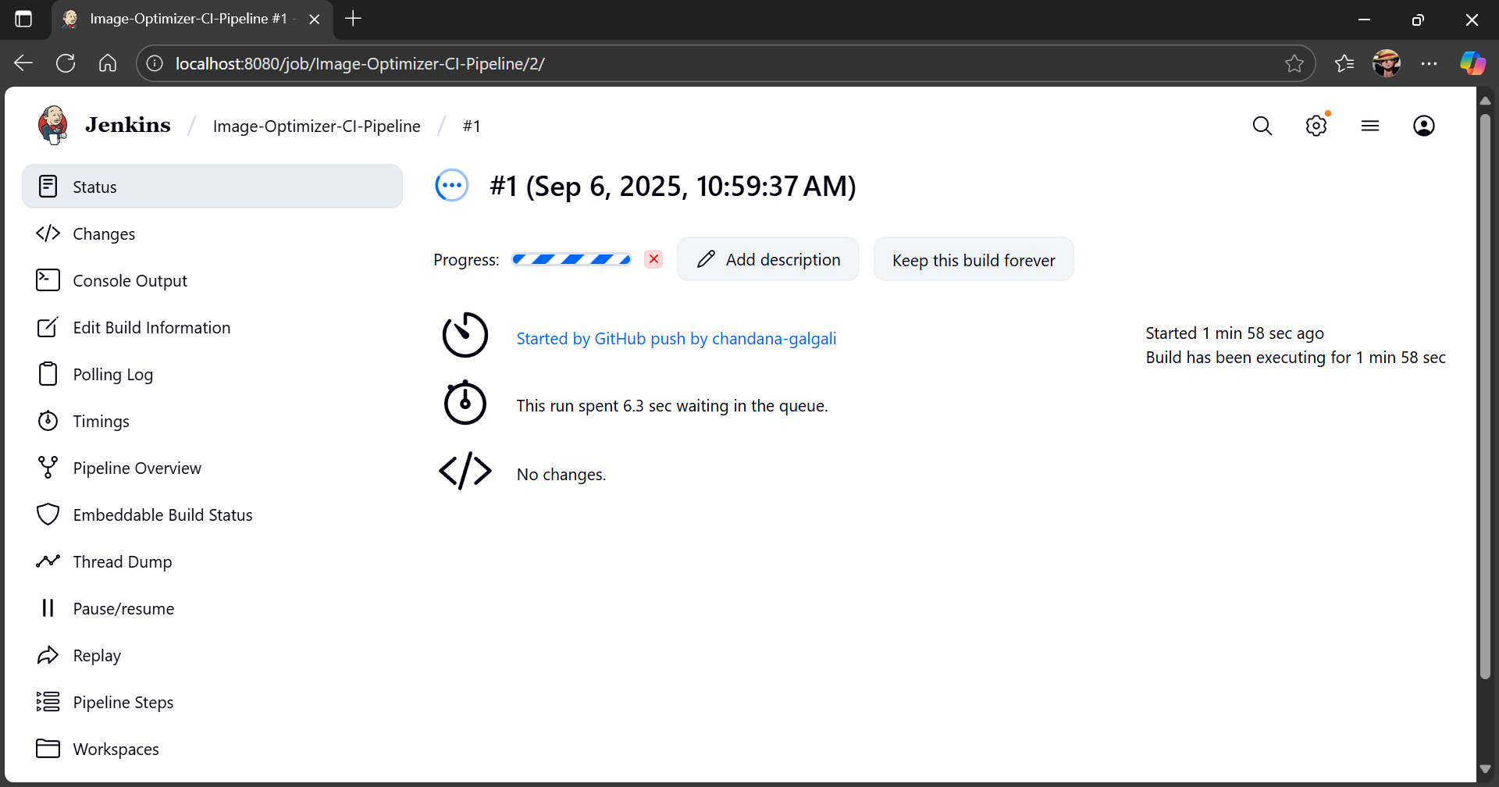

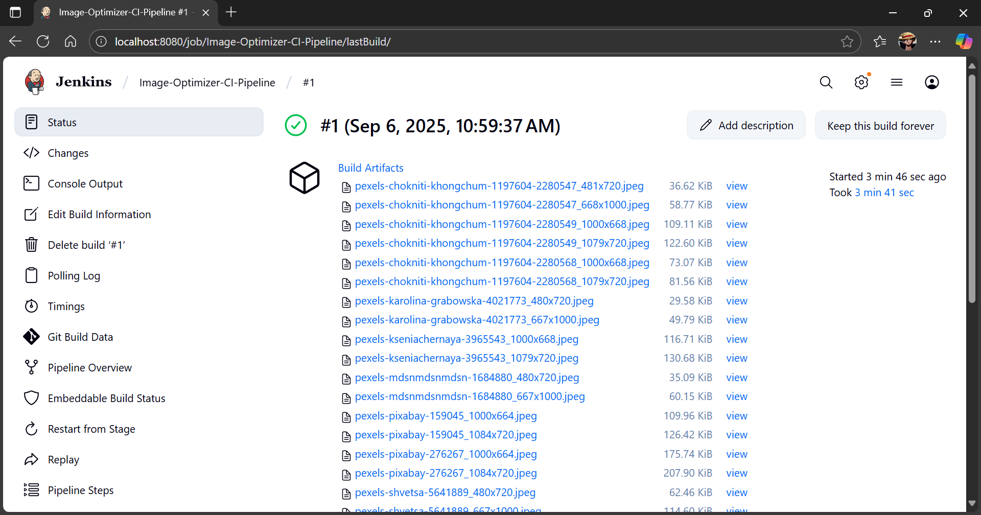

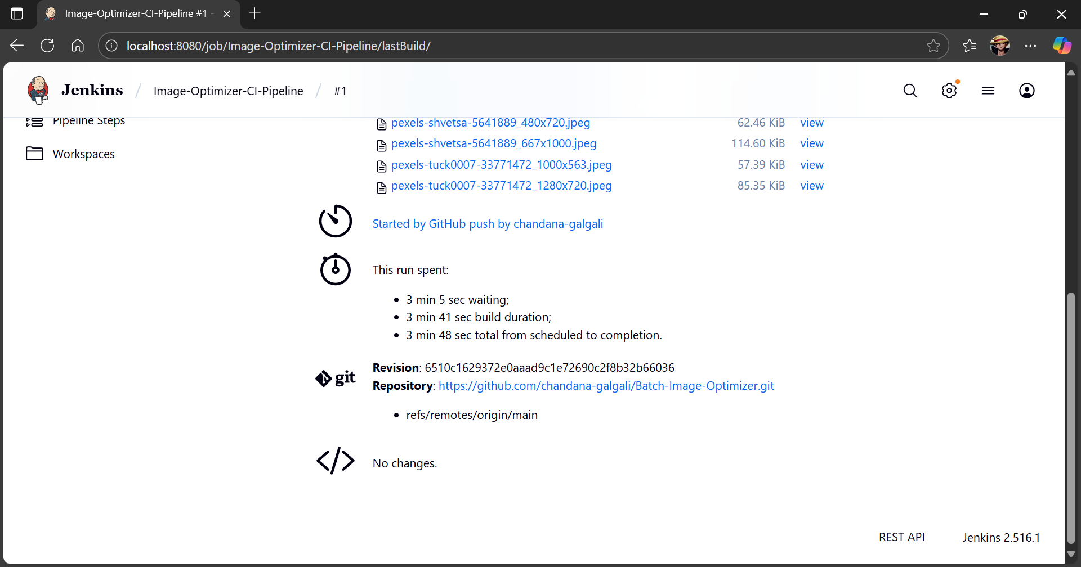

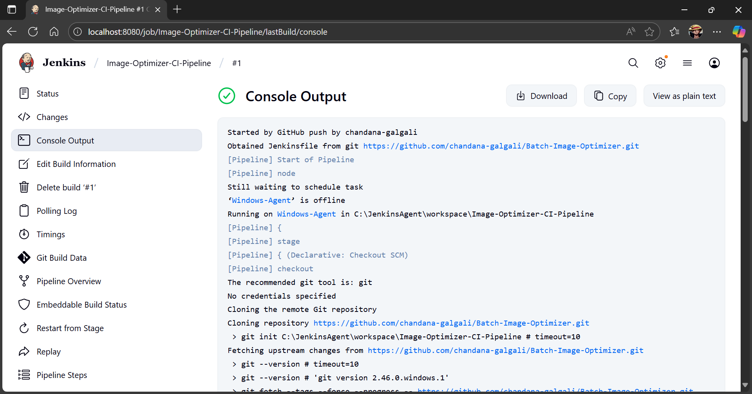

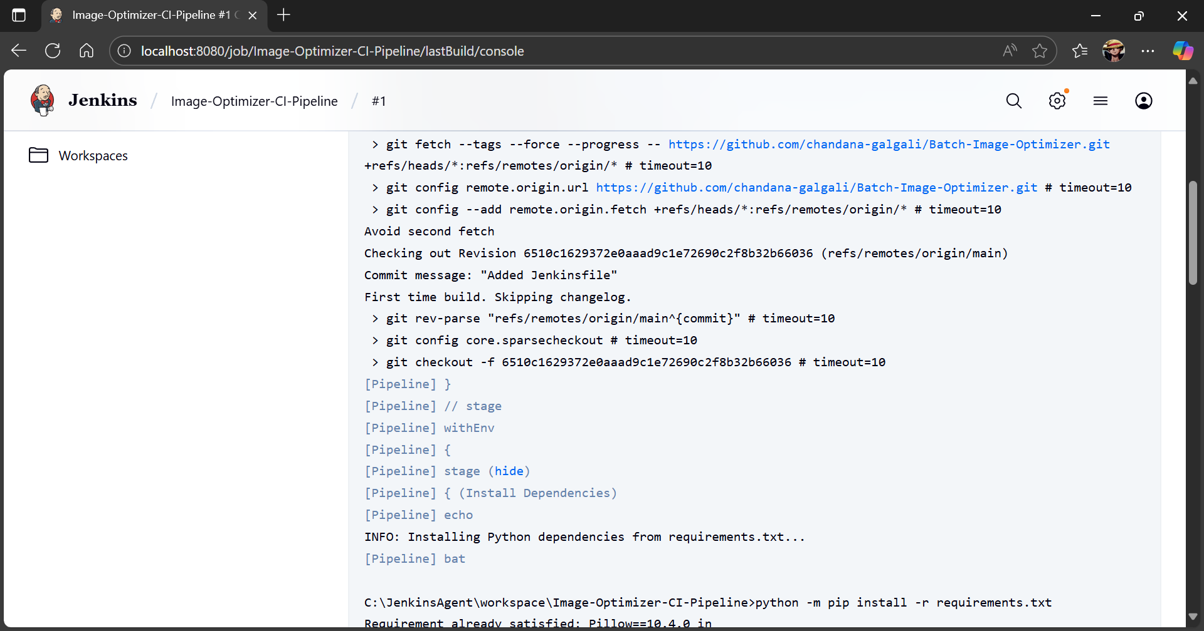

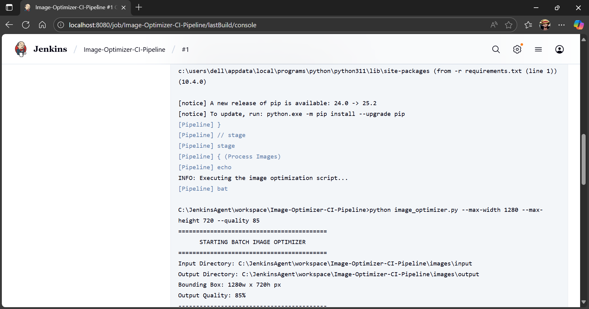

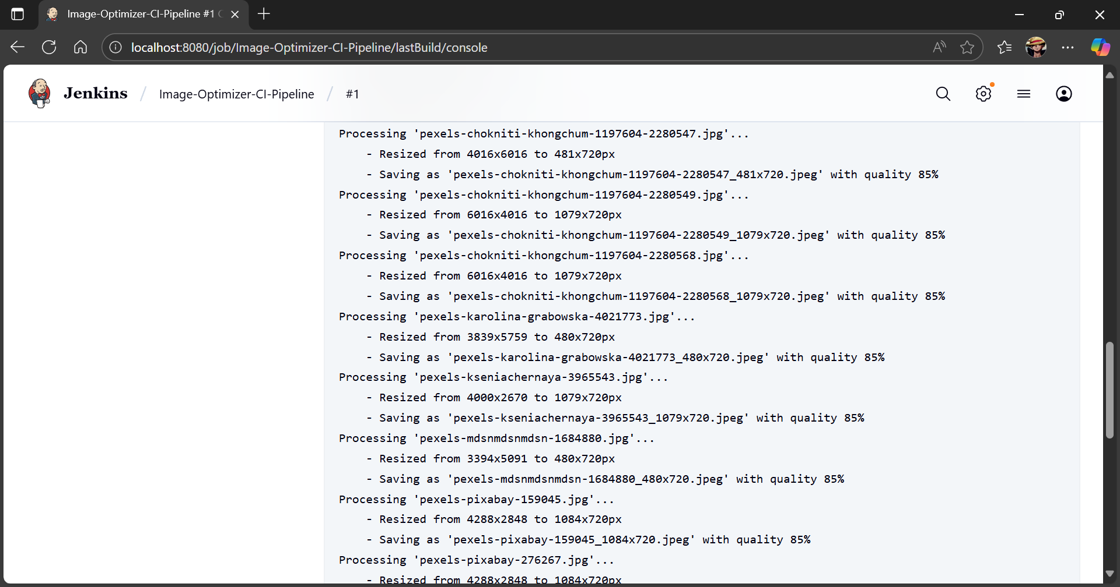

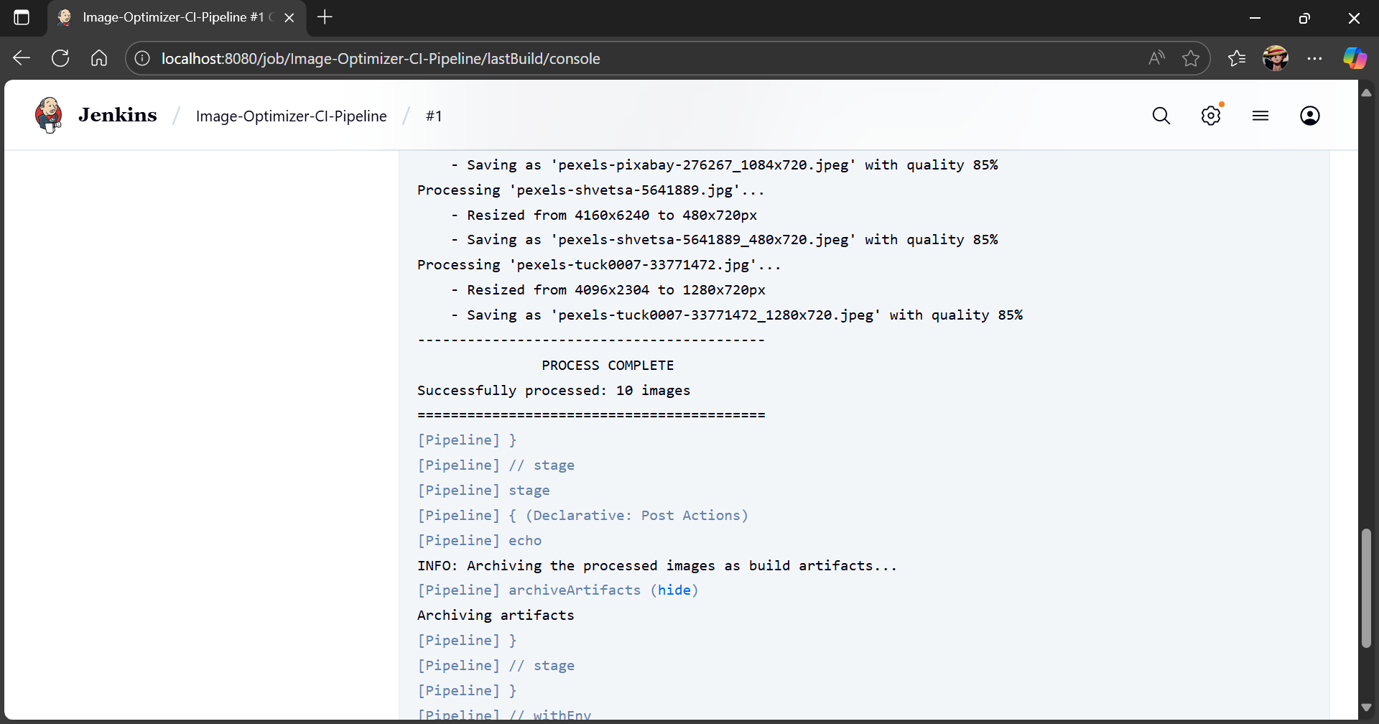

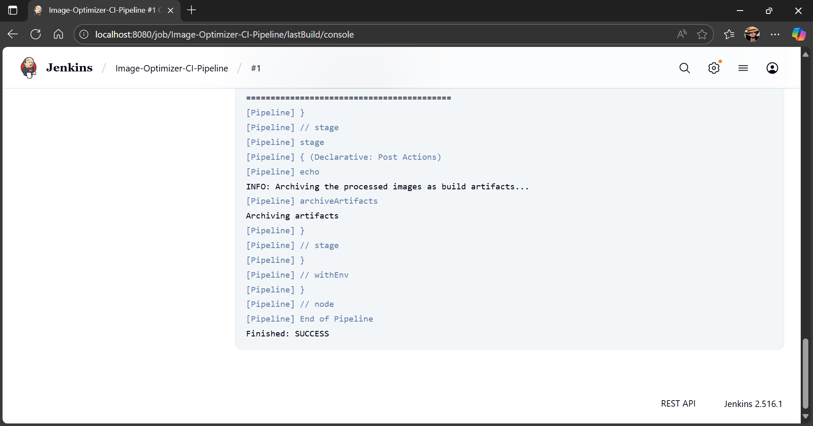

_____________________________________________________________________________

Questions:
- What is Jenkinsfile?
Ans: A Jenkinsfile is a text file that contains the definition of a Jenkins pipeline, which specifies the steps required to build, test, and deploy software in a continuous integration/continuous deployment (CI/CD) environment. The Jenkinsfile outlines the entire process, from fetching the code from the version control system (like GitHub) to performing build tasks, running tests, and deploying the software. This file is usually stored within the project's repository and is executed automatically by Jenkins whenever there are changes or commits in the code. It helps automate the entire CI/CD process, reducing manual intervention and ensuring consistency across builds.
_____________________________________________________________________________

Outcomes: CO3 — Comprehend the effective code building and testing process
_____________________________________________________________________________

Conclusion: (Conclusion to be based on the Results and outcomes achieved)
In this experiment, we successfully integrated Jenkins with GitHub for Continuous Integration (CI) to automate the process of building, testing, and deploying software after each code commit. By configuring Jenkins with GitHub and using a Jenkinsfile to define the build process, we ensured that any changes pushed to the repository were automatically built and tested. This integration allowed us to catch potential errors early in the development cycle, reducing the time taken to identify and fix bugs. The implementation of CI practices enhanced the software development process by ensuring that only the best code was merged into the main branch, which led to more efficient development cycles and improved software quality.
_____________________________________________________________________________

Grade: AA / AB / BB / BC / CC / CD / DD

Signature of faculty in-charge with date
_____________________________________________________________________________

References:
Books/ Journals/ Websites:
- https://guides.github.com/introduction/git-handbook/
- Jenkins Beginner Tutorial 8 - Jenkins integration with GIT (SCM):
https://www.youtube.com/watch?v=bGqS0f4Utn4&t=7s
- Integrate with GitHub: build after each commit (Get started with Jenkins, part 13):
https://www.youtube.com/watch?v=Z3S2gMBUkBo
- https://www.guru99.com/continuous-integration.html
_____________________________________________________________________________

